

**North South University**

Department of Electrical & Computer Engineering

**CSE299.9 (Spring 2025)**

Junior Design

**Project Report**

**Project Name:**

**SmartSkin Diagnosis: AI-Powered Skin Disease Detection System**

**Group Member 1 Name:** Ashraf Sharif

**Group Member 1 ID:** 2211521042

**Group Member 1 Name:** Marzan Islam

**Group Member 1 ID:** 2211102642

**Submitted to:** Mr. Muhammad Shafayat Oshman [MUO]

1. Introduction:

Skin diseases are among the most common health issues globally, affecting millions of people regardless of age or geography. However, many individuals lack access to timely dermatological consultation, especially in rural or underdeveloped regions. With the rise of machine learning and computer vision, we now have the ability to build intelligent systems that assist in disease detection.

**SmartSkin Diagnosis** is an AI-powered web application designed to classify skin diseases from images using deep learning. Users can upload a photo of the affected skin area, and the system predicts the disease class and displays helpful information such as the cause, recommended actions, and prevention tips. This tool is not a replacement for a doctor but serves as a valuable support system for early awareness.

2. Problem Statement:

Access to specialized dermatological care is limited in many parts of the world due to factors like high cost, lack of infrastructure, and long wait times. Delays in diagnosis can worsen skin conditions, especially in children and elderly patients.

Our project aims to address the followingproblems:

* **Social Problem:** Lack of access to affordable and timely skin health diagnosis.
* **Technical Problem**:Need for an intelligent, automated, and accessible system to detect and inform users about possible skin conditions.

# 3. Project Description:

For our Junior Design project, we wanted to build something practical that could solve a real problem, not just another to-do list app or weather forecast project. That’s how we came up with **SmartSkin Diagnosis;** a web-based AI tool that helps identify skin diseases from images using machine learning.

Skin problems are common, but access to dermatologists isn’t. People either Google symptoms and get scared, or just ignore it until it gets worse. So we thought: what if we could use deep learning to give people a quick, early idea of what might be going on with their skin?

### What is SmartSkin Diagnosis?

It’s a web app where you:

* Upload a clear photo of the affected skin area.
* The image gets analyzed by our trained **CNN (Convolutional Neural Network)**.
* The system predicts which of **19 common skin conditions** it might be.
* Then it shows useful info like:
  + What causes the disease
  + Suggested actions to take
  + How to prevent it in the future

# 4. Model Architecture Overview

Our CNN model follows a **deep multi-block architecture**, inspired by VGG-like networks, but optimized to run faster and generalize better on our custom dataset.

#### Model Layers (Step-by-step):

1. **Input Preprocessing:**

* All images are resized to **180x180**.
* Pixel values are scaled between 0–1 using a Rescaling layer.

1. **Feature Extraction (Convolutional Blocks):**

* **Block 1:** Two Conv2D layers (64 filters, 3×3), ReLU + MaxPooling
* **Block 2:** Two Conv2D layers (128 filters, 2×2), ReLU + MaxPooling
* **Block 3:** Two Conv2D layers (256 filters, 2×2), ReLU + MaxPooling
* **Block 4:** Two Conv2D layers (512 filters, 2×2), ReLU + MaxPooling

1. **Flatten + Dense Layers:**

* Flatten the feature maps
* Dense(256) → Dense(128) → Dense(64), all with ReLUFinal output: Dense(num_classes) with **softmax** activation for multiclass prediction

Figure 1: Visualization of the CNN

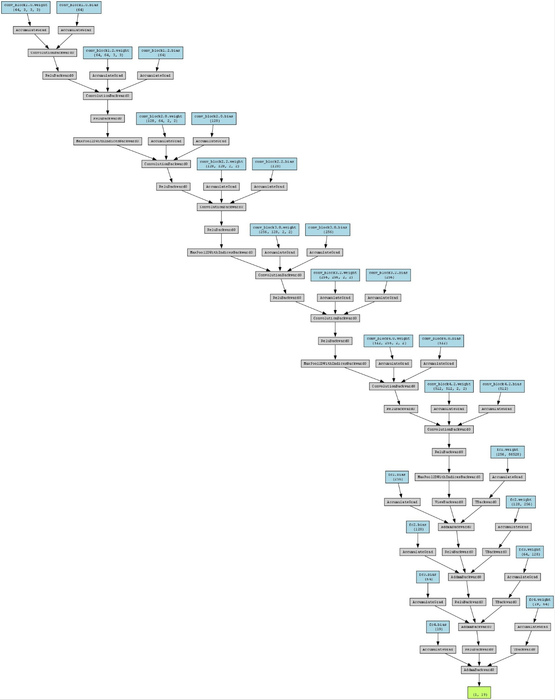

1. **Optimizer & Loss:**

* Optimizer: **Adamax**
* Loss Function: **Categorical Crossentropy**
* Evaluation Metric: **Accuracy**

# 5. Used Technologies:

Here are the technology we used in the system:

**Model Training:**

* Python, TensorFlow (Keras API)
* Trained on a labeled dataset of skin disease images
* Used ImageDataGenerator for augmentation and better generalization
* **Backend:**
  + **Django (Python)** for handling requests and connecting ML model
  + Loads the .h5 model once and runs predictions in real time
* **Frontend:**
  + HTML/CSS for layout
  + JavaScript for dynamically showing prediction details
  + Users interact by uploading an image, and results are shown instantly

# 6. Flowchart:

Figure 2: Flowchart of the program

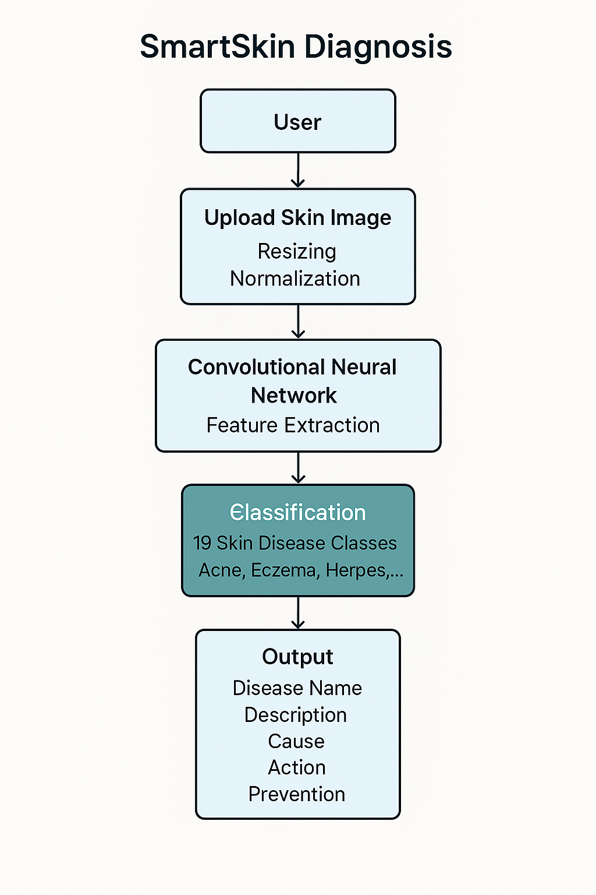

* To run the project we need to open terminal and write

##### python manage.py runserver

* After that we’ll see a prompt like that:

Figure 3: Link to open Django Web Project

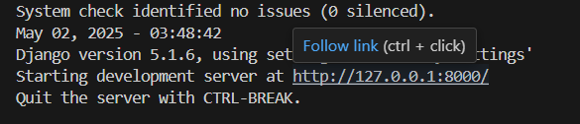

<http://127.0.0.1:8080/>

* After that, we can view our home page of the project.

Figure 4: Homepage of SmartSkin Diagnosis

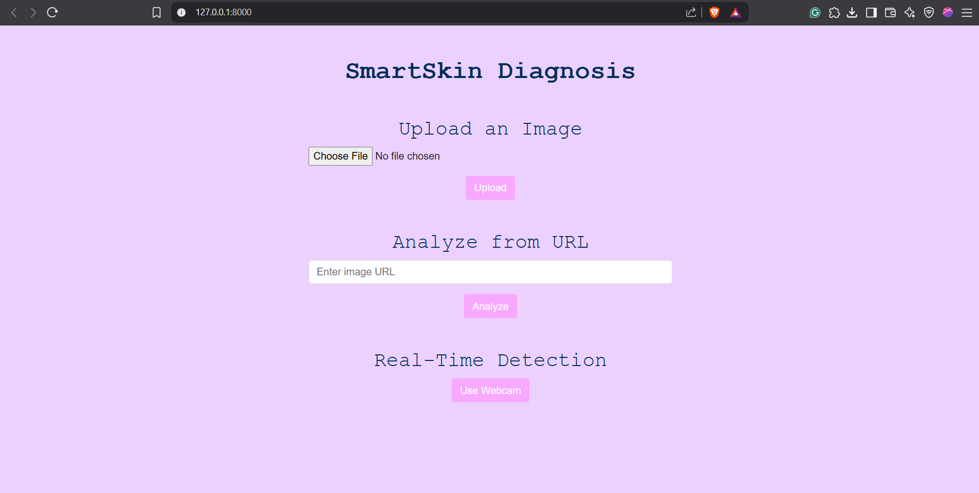

* Then if we choose to upload a file, we can select “Choose File” to upload. The file will be uploaded into the project folder.

Figure 5: Uploading Image

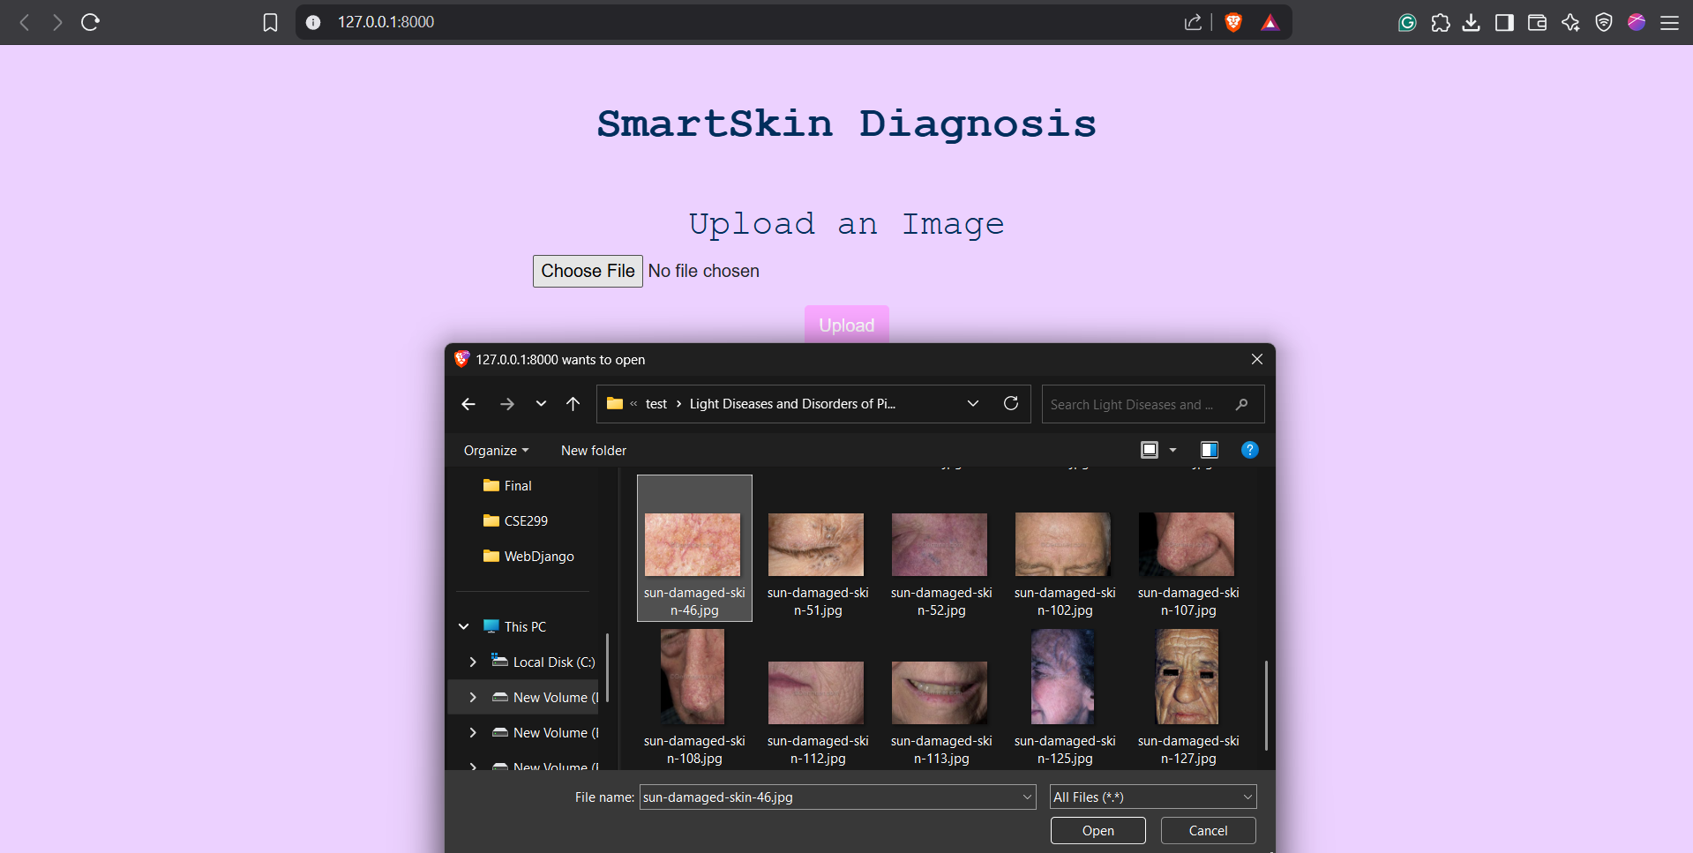

* After uploading the image, we’ll have to wait for the model to predict the disease and then it will show the predicted result.

Figure 6: Predicted Result

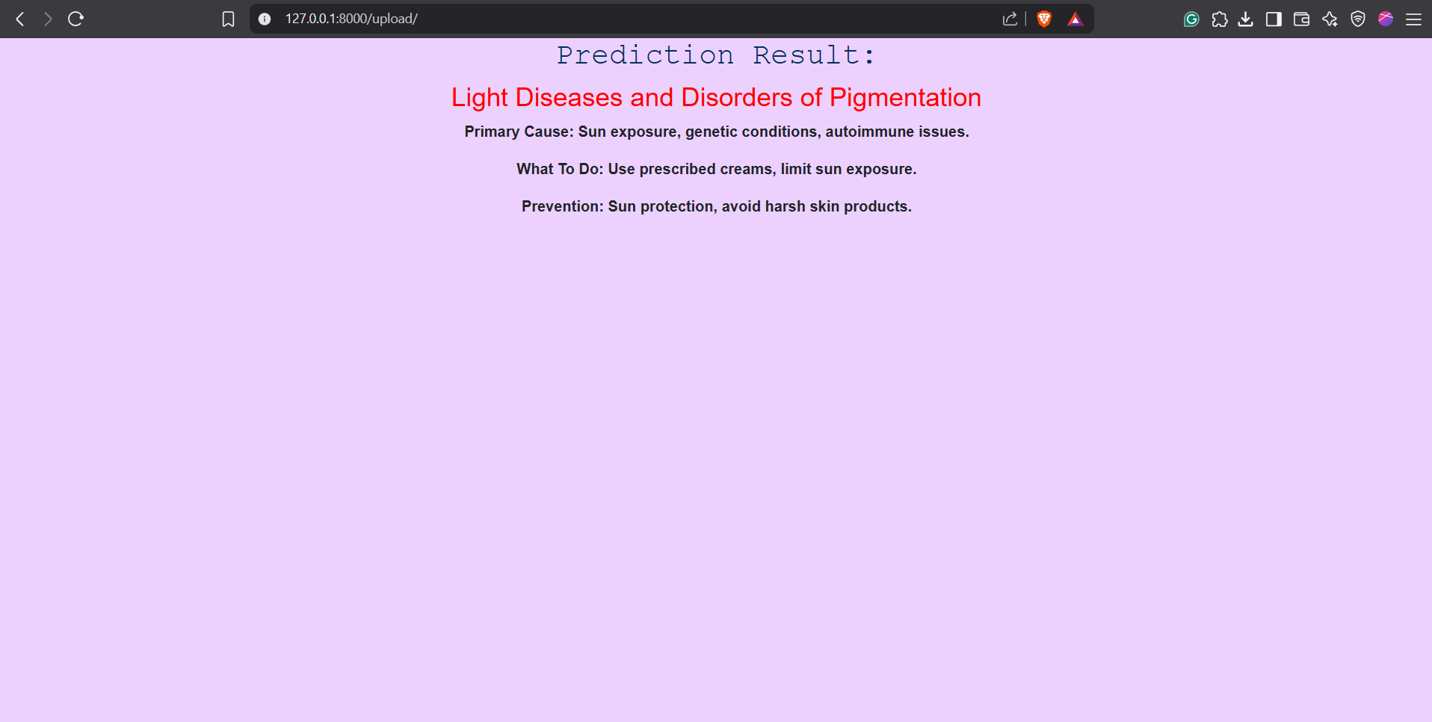

* Now if we want to analyze an image from a URL, we can search any image and then copy and paste the link to the placeholder. Note: We have to make sure that the URL contains “.jpg” image file.

Figure 7: Ringworm Image

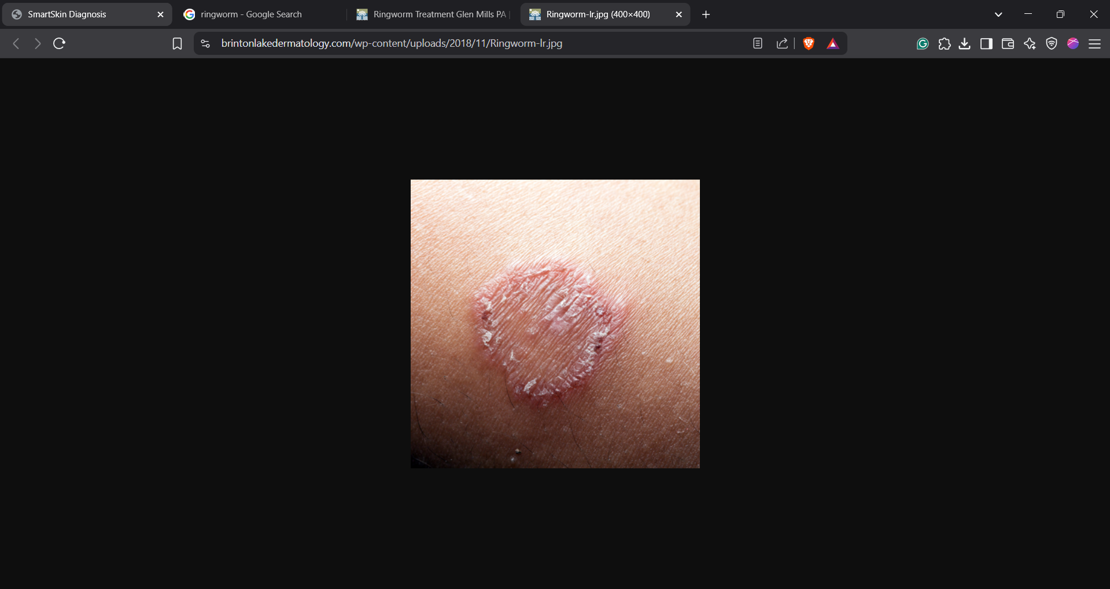

We searched an image or “Ringworm”, then we extracted the image link from the website.

* After that, we need to paste it to the placeholder and we need to press the analyze button.

Figure 8: Enter the link in the placeholde

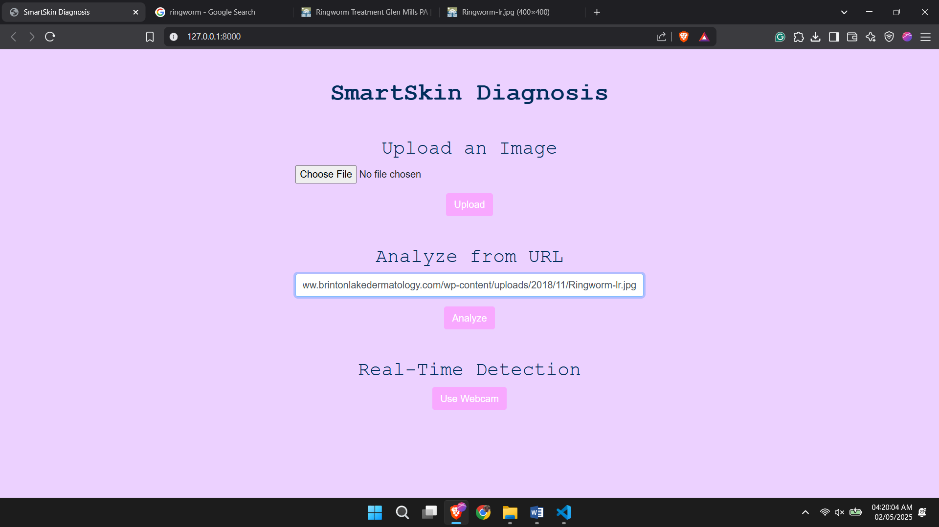

* We got our result and Primary Cause and What to do if this happens and primary prevention techniques.

Figure 9: Predicted Result

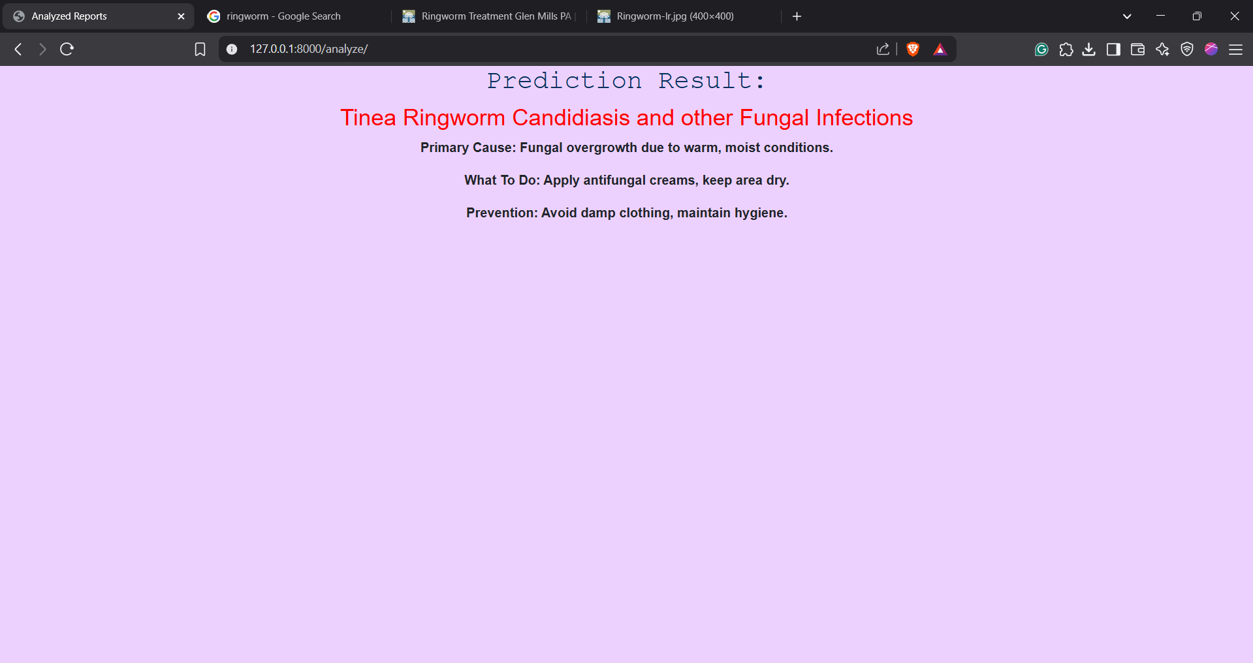

7. GitHub Repository Link: <https://github.com/ashrafshykat/SmartSkin-Diagnosis>

# 8. Conclusion:

SmartSkin Diagnosis is a significant step toward leveraging AI to assist healthcare. By combining deep learning with a user-friendly web interface, it allows non-experts to receive preliminary insights into their skin condition. While it is not meant to replace professional diagnosis, it empowers users with early awareness and encourages prompt medical consultation.

In the future, the system can be enhanced by:

* Expanding the dataset to cover more conditions.
* Deploying a mobile application version.
* Including a multilingual interface.
* Adding a teledermatology consultation feature.